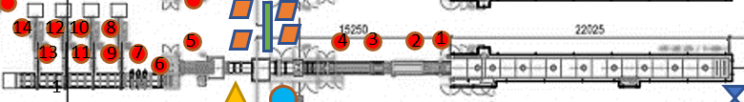

**(Konversi = Karton)**

Oven

* Total Production = S1
* Good = S2
* Reject = S1-S2

Creamer

* Total Production = S2
* Good = S3
* Reject = S2-S3

Cooling

* Total Production = S4
* Good = S5
* Reject = S4-S5

Cutting

* Total Production = S5
* Good = S6
* Reject =S5-S6

Packaging 1

* Total Production = S7
* Good = S8
* Reject =S7-S8

Packaging 2

* Total Production = S9
* Good = S10
* Reject = S9-S10

Packaging 3

* Total Production = S11
* Good = S12
* Reject = S11-S12

Packaging 4

* Total Production = S13
* Good = S14
* Reject = s13-s14

Reject packaging

* Reject = S6-(S7+S9+S11+S13)

Lakban

* Total = S8+S10+S12+S14
* good = S15
* Reject = Total - Good